**[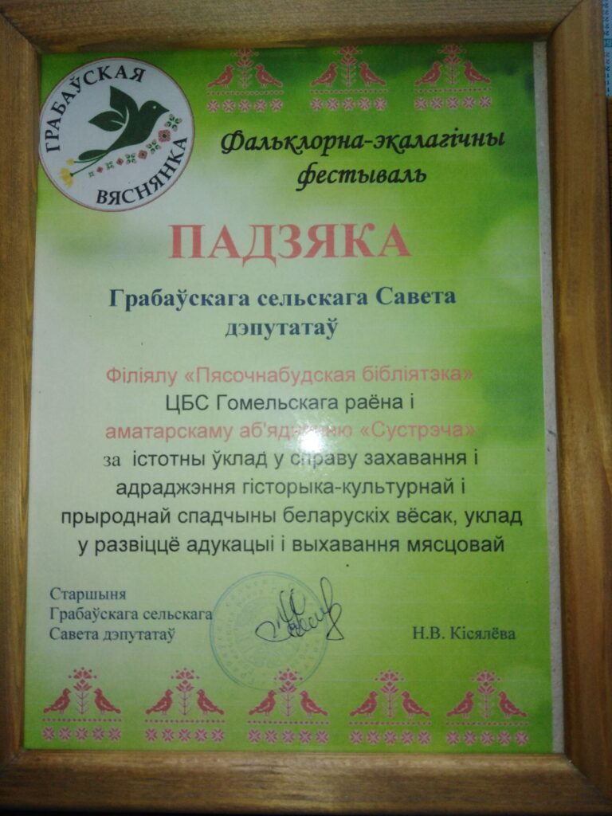](http://gomelrcbs.by/wp-content/uploads/2021/04/IMG_0519.jpg)**

**[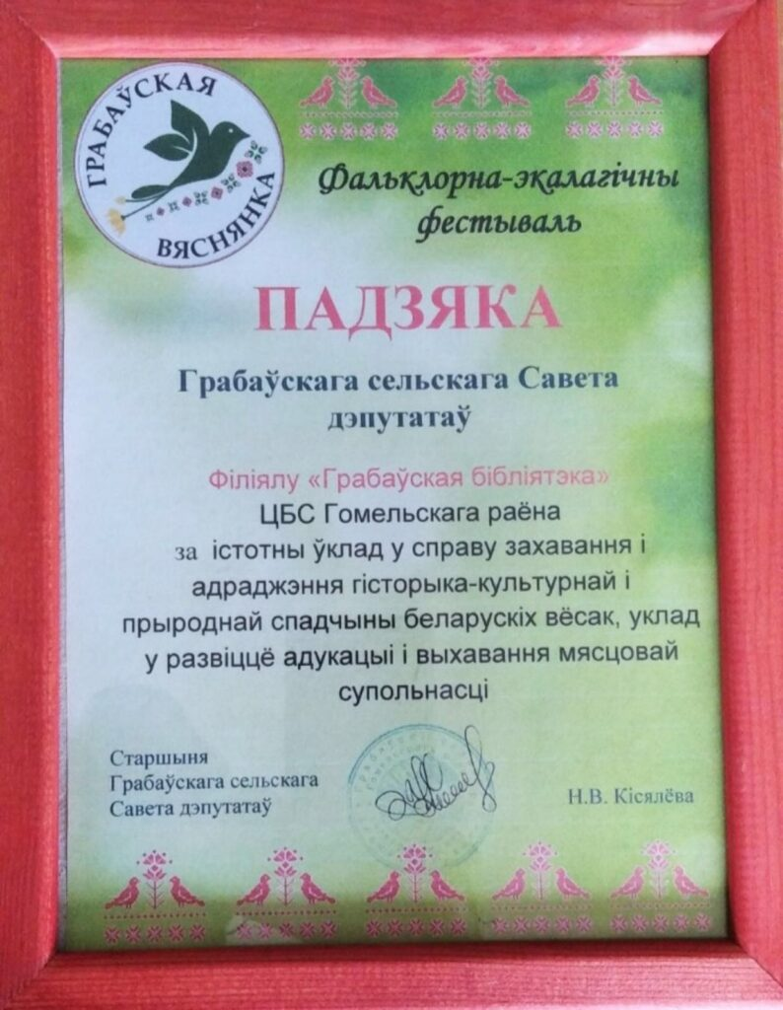](http://gomelrcbs.by/wp-content/uploads/2021/04/IMG_0520.jpg)**

[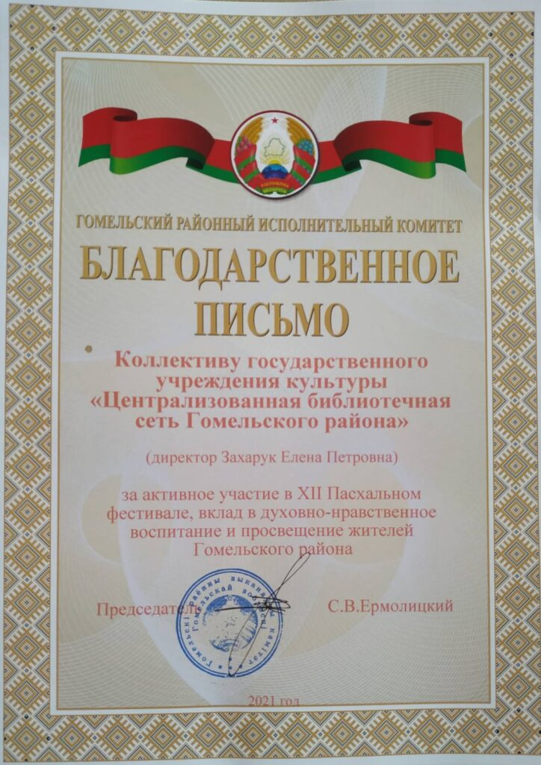](http://gomelrcbs.by/wp-content/uploads/2021/05/IMG_0601.jpg)

[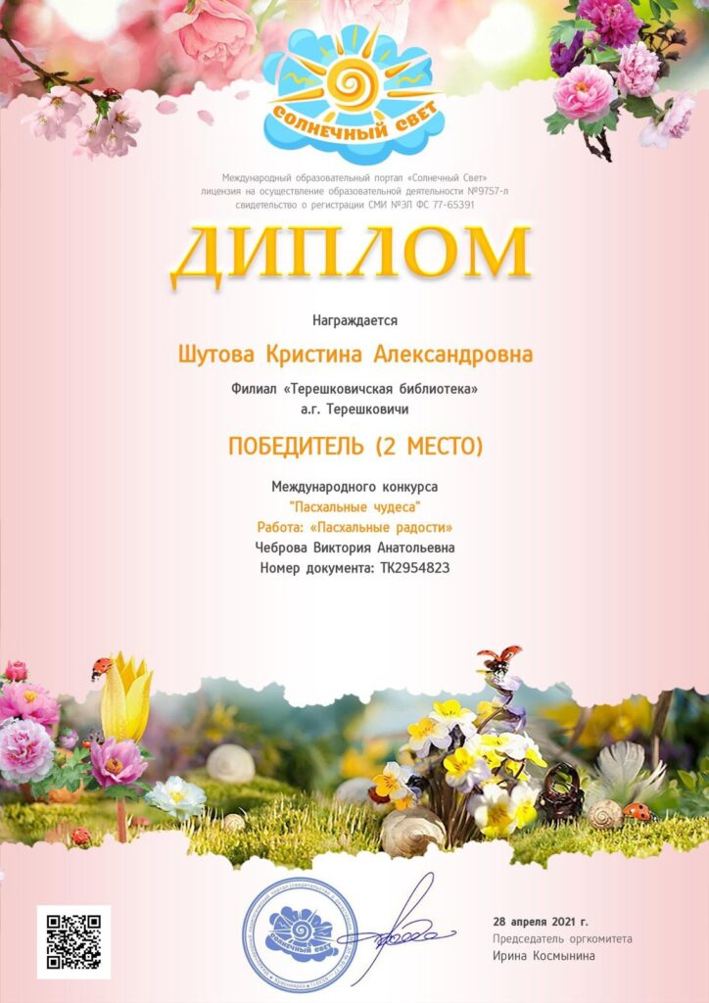](http://gomelrcbs.by/wp-content/uploads/2021/05/IMG_0599.jpg)

[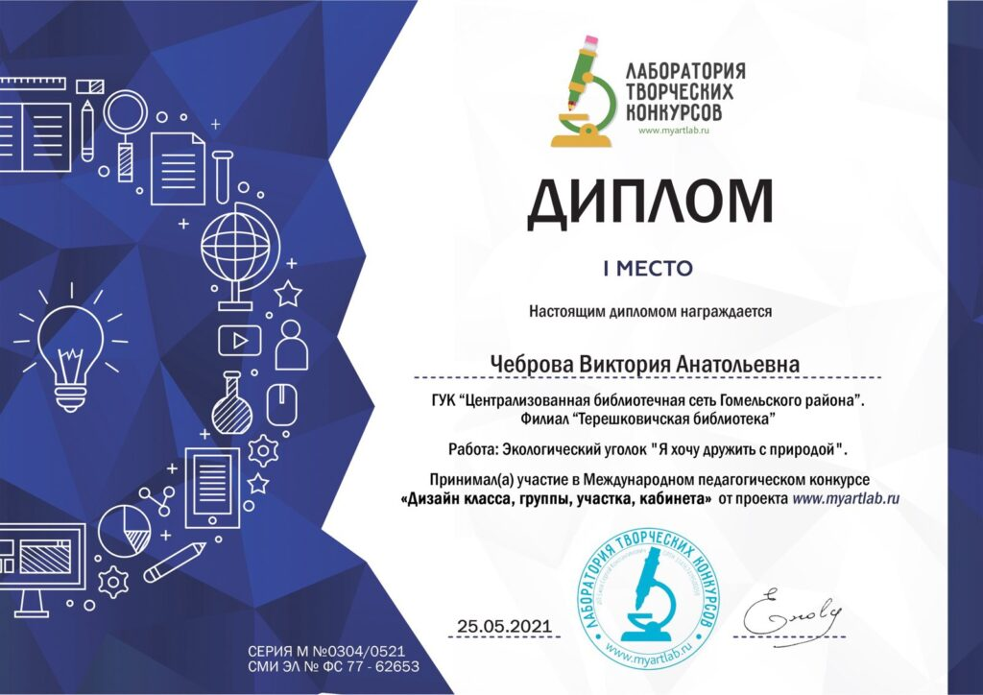](http://gomelrcbs.by/wp-content/uploads/2021/05/IMG_0632.jpg)[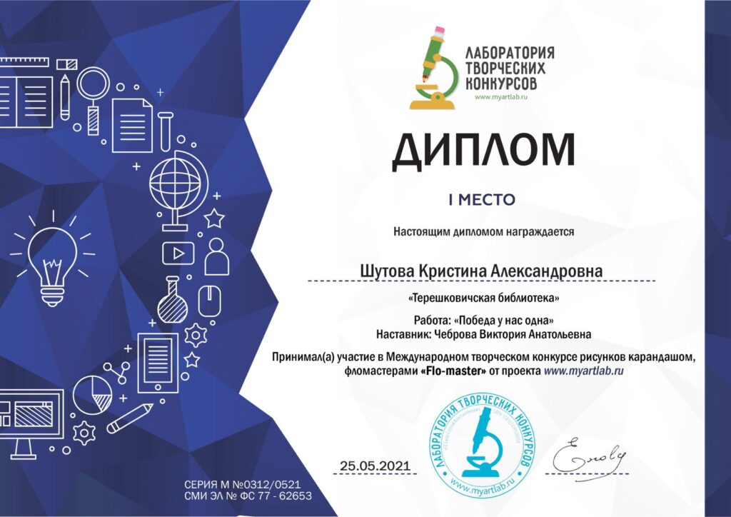](http://gomelrcbs.by/wp-content/uploads/2021/05/IMG_0600.jpg)

**[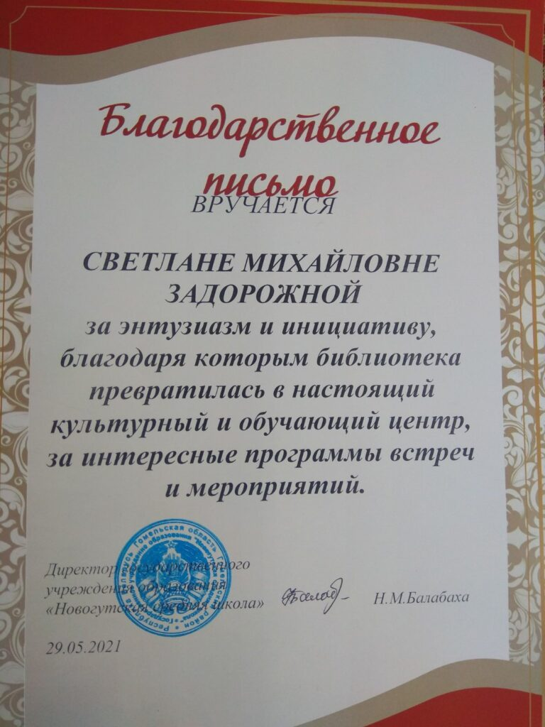](http://gomelrcbs.by/wp-content/uploads/2021/05/IMG_0631.jpg)**

[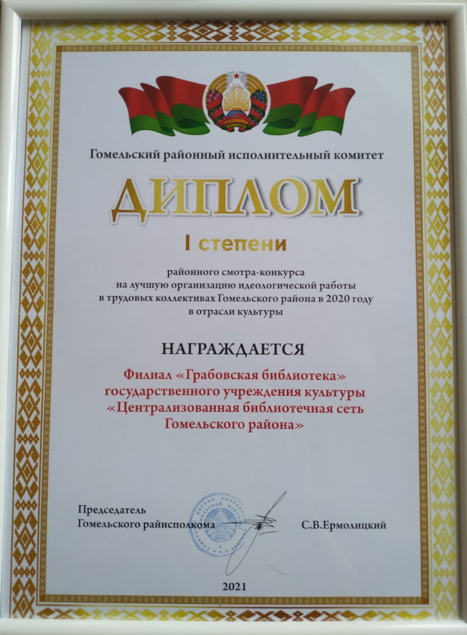](http://gomelrcbs.by/wp-content/uploads/2021/11/изображение_2021-11-17_104941.png)

**[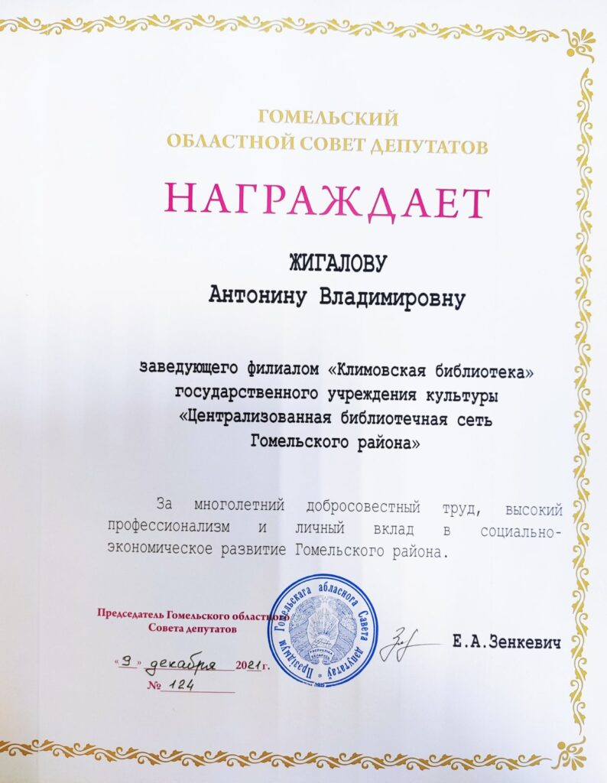](http://gomelrcbs.by/wp-content/uploads/2021/12/изображение_viber_2021-12-11_08-41-49-886.jpg)**